**Assignment-11**

**Build Scaling Plans in AWS that Balance Load on Different EC2 Instances**

# Objective:

To create an Auto Scaling environment with EC2 instances and Elastic Load Balancer (ELB) that automatically handles traffic and manages high availability using a GitHub repo with a Node.js app.

# 🔧 Part 1: Create a Launch Template

## Go to EC2 Dashboard

* + Log in to your AWS Management Console.
  + 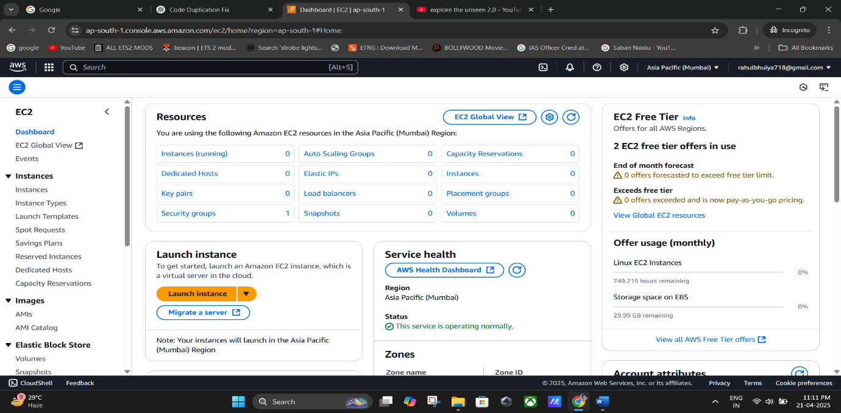Navigate to **EC2** from the Services.

## Create a Launch Template

* + On the left sidebar, click **“Launch Templates”**.
  + Click **“Create Launch Template”**.
    - **Template name**: e.g., MyTemplate-1
    - **Template version description**: Optional
    - **Check the box** for **“Provide guidance to help me set up a template that can be used with EC2 Auto Scaling”**

## Configure Launch Template

* + **Amazon Machine Image (AMI)**: Select **Ubuntu**.
  + **Instance Type**: Choose **t2.micro**.
  + **Key Pair**:
    - If you already have one, select it.
    - If not, click **“Create a new key pair”**, download the .pem file.

## Network Settings

* + Under **Network settings**, select the **Security Group** you previously created (e.g.,

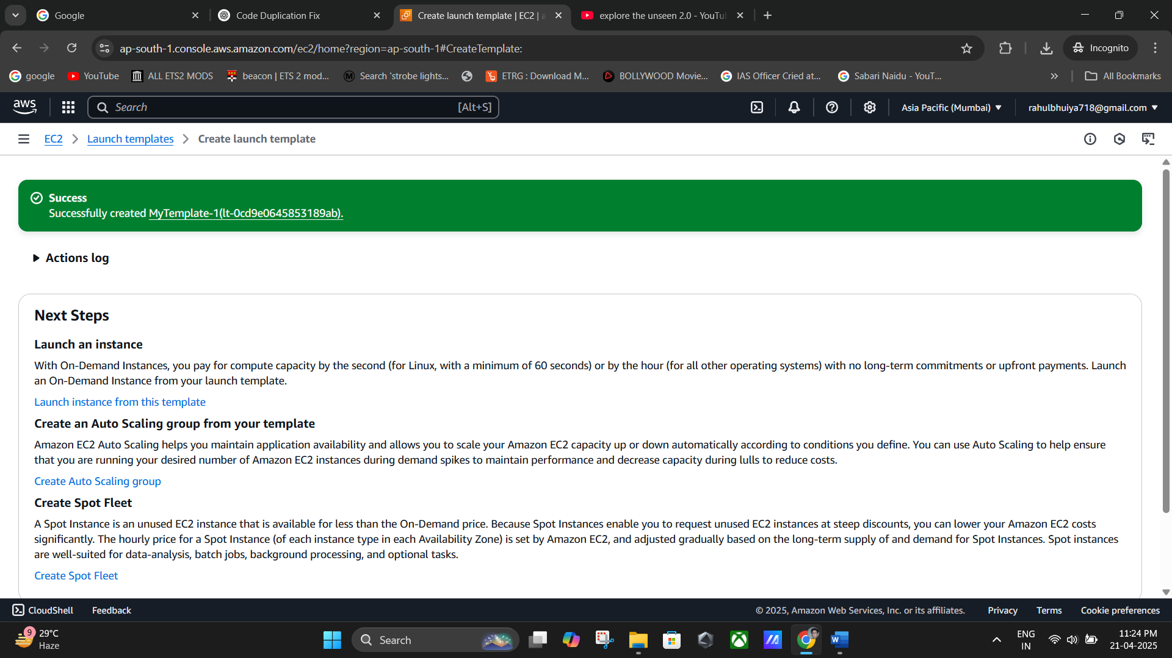MyTemplate-1).

# 📦 Make Sure GitHub Repository is Public

If your Node.js GitHub repo is private:

* + Go to **GitHub → Repo Settings → Scroll down to "Danger Zone"**.
  + Click **“Change repository visibility”** and make it **Public**.

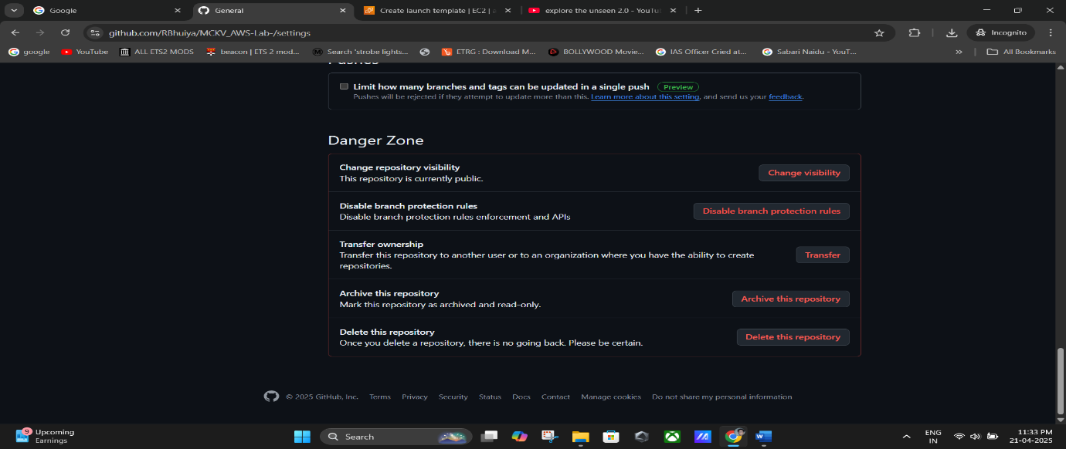

# Part 2: Create an Auto Scaling Group

## Go to Auto Scaling Groups

* + In EC2 Dashboard → Click **“Auto Scaling Groups”**
  + Click **“Create Auto Scaling Group”**

## Configure Group Settings

* + **Name**: e.g., MyAutoScale-1
  + **Launch Template**:
    - Choose the launch template created earlier (e.g., mytemplate1)
    - Select **Latest version (1)**

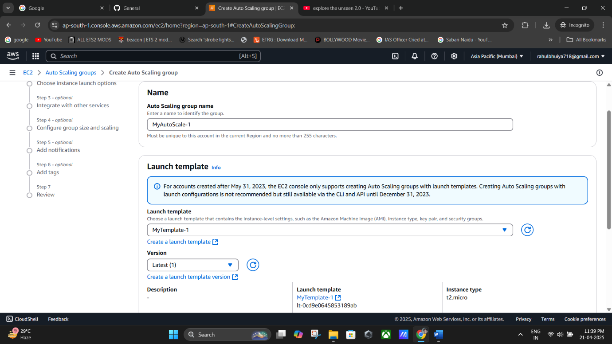

**(“Auto Scaling Group”-> Configure Group Settings).**

## Add User Data (Startup Script)

Paste the following script into **“User data”** section:

#!/bin/bash apt-get update

apt-get install -y nginx systemctl start nginx systemctl enable nginx apt-get install -y git

curl -sL https://deb.nodesource.com/setup_18.x | sudo -E bash - apt-get install -y nodejs

git clone https://github.com/<your-username>/<your-repo-name> cd <your-repo-name>

npm install node index.js

➡️ **Replace** https://github.com/.../... and cd ... with your actual GitHub repo URL and folder name.

## Select Network Options

* + **Availability Zones and Subnets**: Select **all available subnets** to ensure high availability.
  + 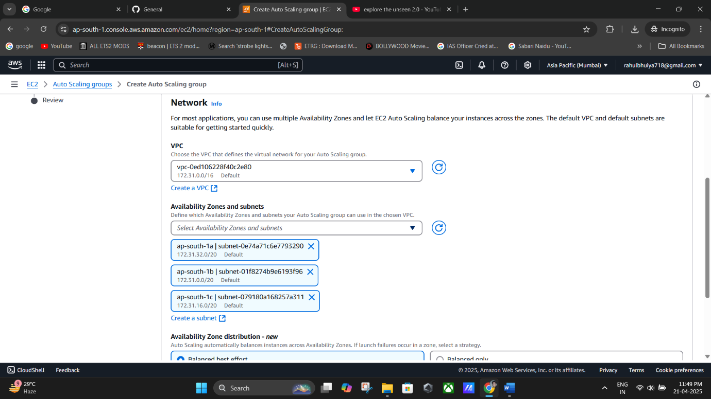Click **Next**.

## Attach Load Balancer

* + In **Load Balancing** section:
    - Choose **“Attach to a new load balancer”**
    - **Load balancer scheme**: Internet-facing
    - 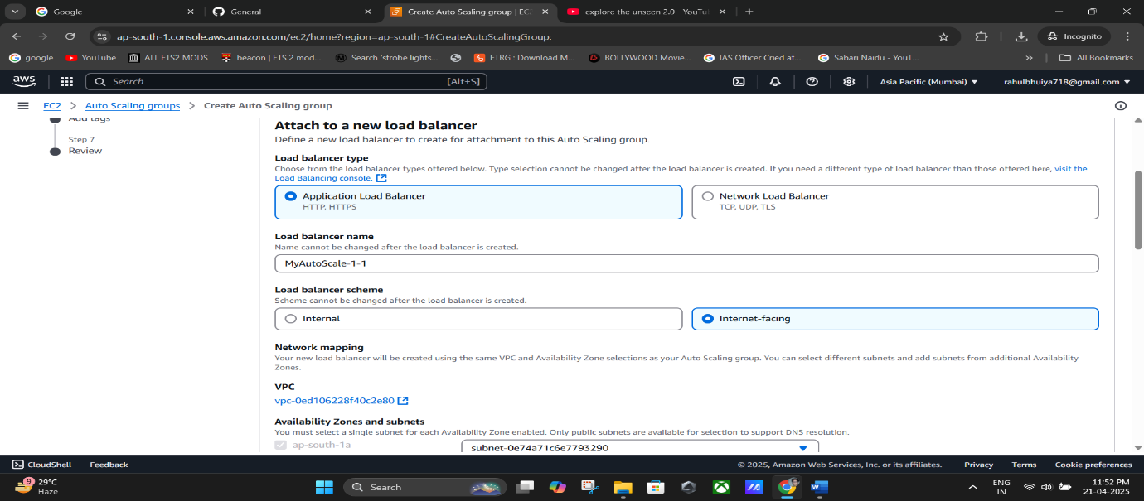**Listener Port**: 4000
    - **Default routing**: Select the created Auto Scaling Group.

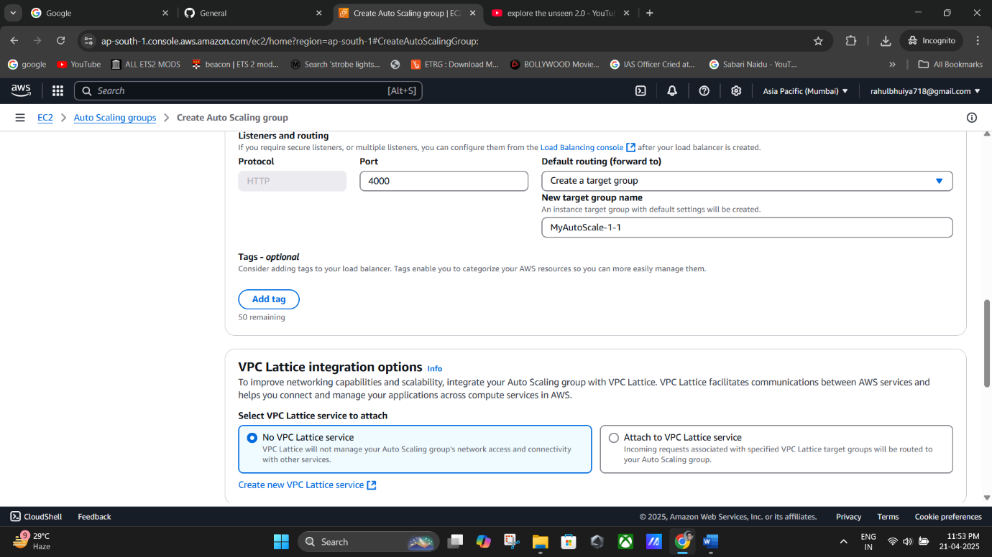

(**Load balancer scheme**: Internet-facing-> **Listener Port**: 4000).

## Configure Group Size

* + **Desired Capacity**: 2
  + **Minimum Capacity**: 2
  + **Maximum Capacity**: 3

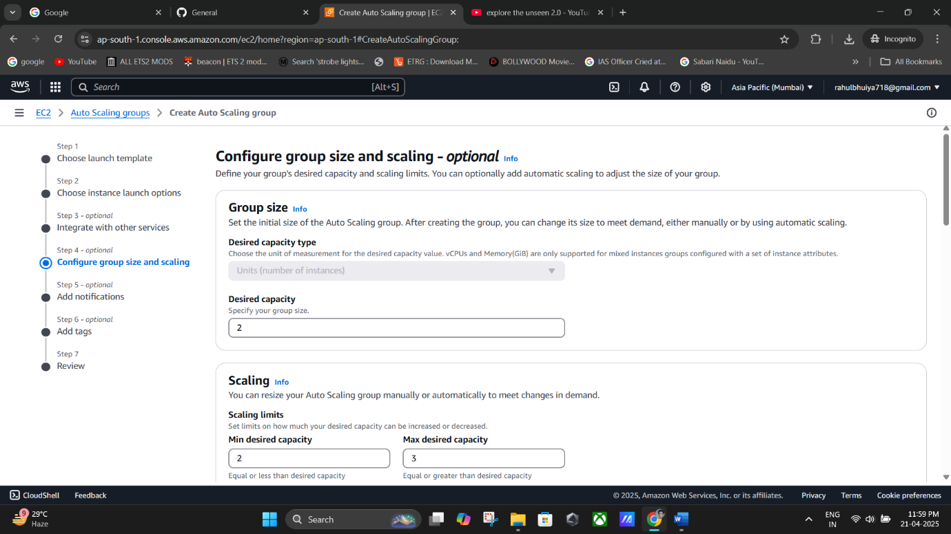

## Set Scaling Policy

* + Choose **“Target tracking scaling policy”**
  + Set **Target value**: 300 (this refers to CPU utilization target)

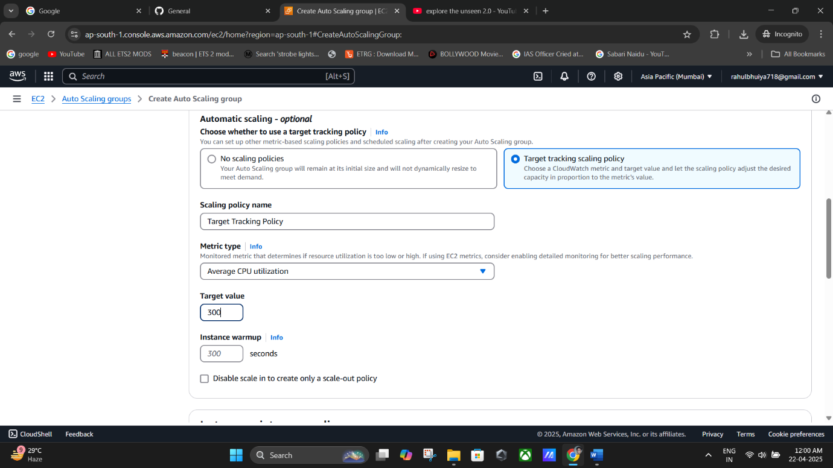

## Review and Create

* + Click **Next** and then **Create Auto Scaling Group**

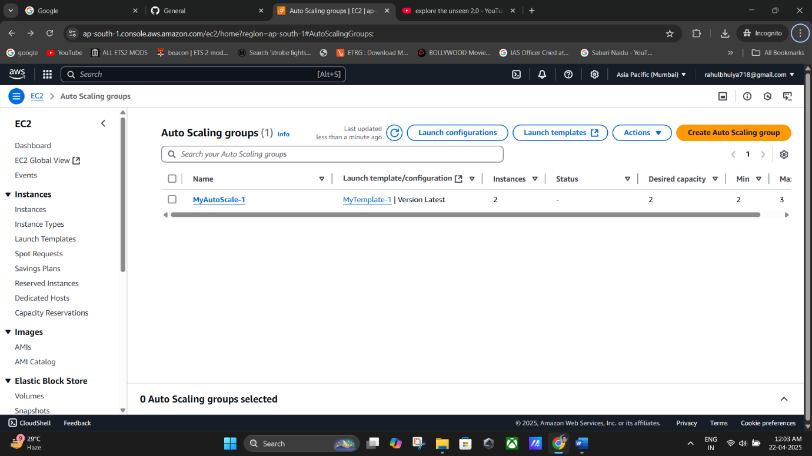

**(Successfully Created Auto Scaling Group).**

# Part 3: Simulate Load (Crash Servers)

## For Server 1 (Using Bitvise SSH Client)

* 1. Copy the **Public IPv4 Address** of one EC2 instance.
  2. Open **Bitvise SSH Client**:
     + **Host**: Paste IP address
     + **Username**: ubuntu
     + **Authentication method**: Public key
     + Load your .pem key file in **Client Key Manager**
     + Click **Login**

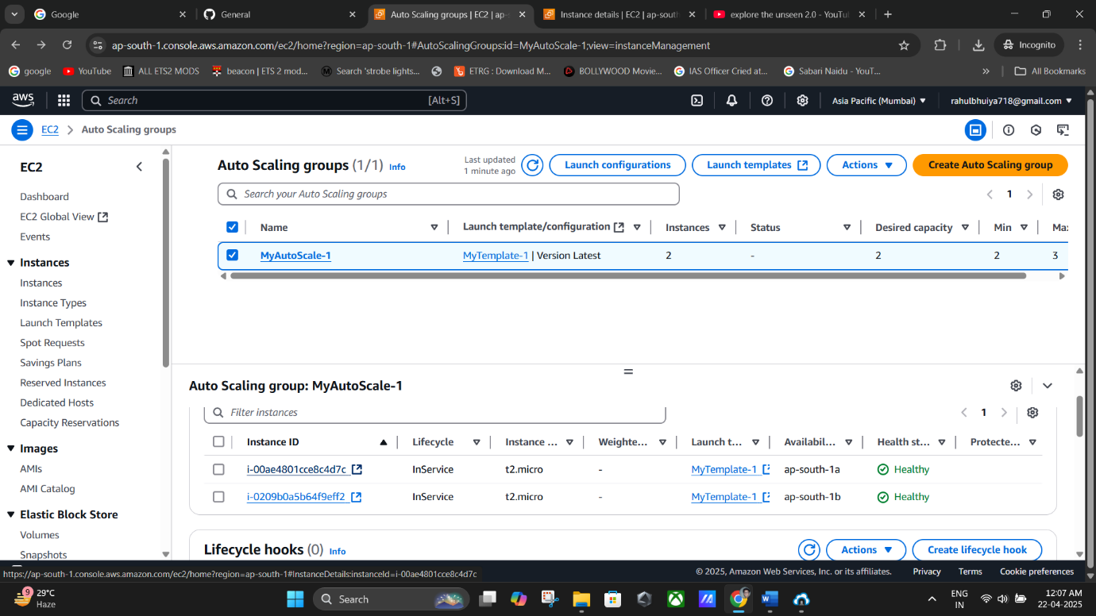

**(Copying the Public IPv4 Address of one EC2 instance).**

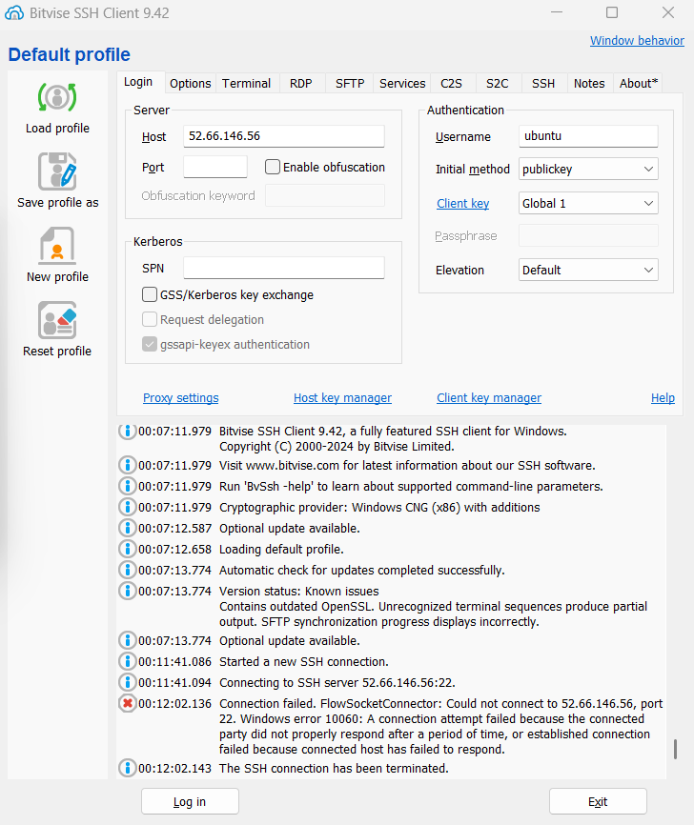

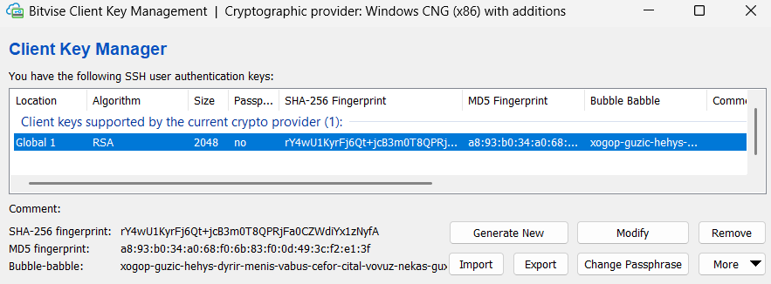

* 1. In Terminal:
     + Create an infinite loop script:
     + sudo nano infi1.sh

Add:

#!/bin/bash while true do

echo "Looping forever"

# Additional commands can be added here done

* + - Save the file, then run:
    - sudo chmod +x infi1.sh
    - ./infi1.sh

## For Server 2 (AWS Connect Terminal)

1. Go to EC2 → Select second instance → Click **Connect**
2. In terminal, repeat same steps:
3. sudo nano infi1.sh
4. sudo chmod +x infi1.sh
5. ./infi1.sh

# 📊 Monitor CPU Utilization

* + Go to **CloudWatch** or EC2 Monitoring tab.
  + As the CPU load increases due to infinite loops, new instances will automatically be launched by Auto Scaling group to handle the load.

# 🗑️ Part 4: Clean Up Resources

## Delete in This Order:

1. **Auto Scaling Group** → Actions → Delete
2. **Load Balancer** → Actions → Delete
3. **Target Group** → Actions → Delete
4. **Launch Template** → Actions → Delete
5. **Running EC2 Instances** → Select → Instance state → Terminate